GUIDELINES:

Responding to non-fatal strangulation, sexual choking and acquired brain injury

July 2024

This referral pathway and protocol is   
designed to improve responses to women   
who have experienced non-fatal strangulation and/or sexual choking, and who may be suffering from an acquired brain injury. It will be useful to service providers working with women who have experienced strangulation and brain injury in the context of domestic, family and sexual violence, and with women who participate in sexual choking.

All practice standards outlined within this referral pathway and protocol are evidence-based. They were informed by a variety of sources, including current NSW clinical practice guidelines; domestic, family and sexual violence management standards; and expert advice.

When using this referral pathway and protocol, you are reminded to proactively engage with the client to understand their cultural identity, intersecting marginalisations and life experiences, and consider how these factors should inform any referrals.

**Ask yourself:**   
Will this service be culturally   
safe, accessible, affordable   
and acceptable to my client?

Table of contents

[At a glance: Strangulation in the context   
of domestic, family and sexual violence   
referral pathway 2](#_Toc170687904)

[At a glance: Sexual choking referral   
pathway 3](#_Toc170687905)

Protocol 4

Key definitions 4

[Responding to strangulation, sexual choking   
and acquired brain injury 5](#_Toc170687908)

Referral pathway 10

Disclosure of strangulation in the context of domestic, family and sexual violence 10

Referral pathway 20

[Disclosure of strangulation in the context of   
sexual choking 20](#_Toc170687912)

Statewide Service Directory 28

Initial medical response 28

Safety response 29

Short- and long-term response 30

List of figures

[**Figure 1** At a glance: Strangulation in the   
context of domestic, family and sexual violence referral pathway 2](#_At_a_glance:)

[**Figure 2** At a glance: Sexual choking referral   
pathway 3](#_At_a_glance:_1)

**Figure 3** Effective response 5

**Figure 4** Signs of life-threatening injury 11

**Figure 5** Significant signs and symptoms of strangulation 11

**Figure 6** Signs of life-threatening injury 21

[**Figure 7** Significant signs and symptoms of   
sexual choking 21](#Figure67)

FIGURE 1

# At a glance: Strangulation in the context of domestic, family and sexual violence referral pathway

Legal   
support

Children’s health and wellbeing

Mental, psychological, psychosocial and community support

Medical   
follow-up

Case management

**Mandatory reporting**

Complete if the client is 17 years or younger or they disclose a child was present during the incident.

Call 000, if you believe the woman or her children are in immediate danger.

Discuss options with client including formal police report, an online police report (SARO), and sexual assault services.

**Domestic and family violence, no immediate danger**

**Sexual violence, no immediate danger**

**Immediate danger**

Health promotion ideally with resources.

Call 000 and inform onsite doctor and/or nurse.

Referral to emergency department using medical referral template (if safe to carry). If client refuses, provide GP referral.

Refer to primary health services (GP, neuro OT) or emergency department if symptoms significant or local criteria allows.

**Signs of life-threatening injury**

**No significant signs and symptoms**

**Support to attend**

**local emergency department**

**New or evolving neurological symptoms**

**What is the safety need?**

**Disclosure of strangulation in the context of domestic, family and sexual violence**

Discuss risk with   
client, including possible police involvement. Consider Safety Action Meeting (SAM) referral as per your organisational practices.

**What is the initial medical need?**

**What are the client’s short- and long-term needs?**

**Historical strangulation (more than 7 days)**

**Recent strangulation (within 7 days)**

FIGURE 2

# Women’s Health NSW logo.At a glance: Sexual choking referral pathway

**Disclosure of sexual choking**

While sexual choking can initially be consensual, some women later redefine it as sexual violence and/or part of coercive control.

Use the terminology and context the woman employs at the screening stage and leave possible reframing to therapeutic sessions.

**Recent sexual choking (within 7 days)**

**Historical sexual choking (more than 7 days)**

**What is the initial medical need?**

If the client describes sexual choking as a form of violence, move to referral pathway *Disclosure of strangulation in the context of domestic*, *family and sexual violence*.

**Is there a safety need?**

Refer to primary health services (GP, neuro   
OT) or emergency department if symptoms significant   
or local criteria allows.

**No connection to violence**

**Connected to violence**

**New or evolving neurological symptoms**

**Support to attend local emergency department**

**Signs of life-threatening injury**

**No significant signs and symptoms**

Health promotion ideally with resources.

Referral support to emergency department using medical referral template. Consider client preference and GP referral.

If appropriate, discuss the long-term health and legal consequences of engaging in sexual choking.

**What are the client’s short- and long-term needs?**

Mental, psychological, psychosocial and community support

Medical follow-up

Legal support

Health promotion

Call 000 and inform onsite doctor and/or nurse.

# Protocol

## Key definitions

### Non-fatal strangulation

Strangulation is any pressure applied to the neck compressing or blocking airflow and/or blood flow going to or from the brain. Strangulation can occur when someone manually puts pressure on the victim’s neck (using one or two hands), when someone comes from behind and puts the victim in a chokehold, when someone pin the victim against a wall, or via the use of a ligature (anything that can be wrapped around the victim’s neck, such as a belt, scarf, cord or rope). Strangulation is non-fatal in situations where the victim survives having pressure applied to their neck by whatever means. Non-fatal strangulation can take place in situations of sexual assault and intimate partner violence, and in sexual choking.

### Sexual choking

Sexual choking is a popular term for strangulation enacted with consent in a sexual context. Specific and informed consent for sexual choking is important. This means considering whether the participant gave affirmative and enthusiastic consent, whether they have accurate knowledge of the health and legal implications of sexual choking, and whether their consent was extracted under coercive control. Some women who describe sexual choking as consensual may later redefine it as sexual violence and/or part of coercive control as they unpack their experiences in therapeutic settings. By meeting each woman where she is at, we can ensure women engaging in sexual choking do not get isolated and can access the support they need. The goal is to provide women with accurate information, so they can make informed decisions about their own health and wellbeing.

### Suffocation and other forms of breath restriction

Airflow can be restricted in ways that do not include pressure being directly applied to the neck, such as by covering and blocking the mouth (smothering/suffocation), or by having pressure applied to the chest (mechanical asphyxia), such as someone sitting on the chest. Although not strangulation, these acts are covered in the same part (s 37) of the Crimes Act 1900 (NSW) and can have similar impacts on a woman’s health and wellbeing. This referral pathway and protocol is specifically designed for strangulation, however, in some circumstances it will be suitable (in consultation with your line manager) for clients who have experienced other forms of breath restriction.

### Acquired brain injury

A brain injury is an injury that causes structural or functional changes to the brain which may be temporary or permanent. “Acquired brain injury” is an umbrella term for a brain injury that occurs after birth. Strangulation can cause an acquired brain injury due to a lack of oxygen (hypoxic/anoxic brain injury). Acquired brain injuries can also be caused by trauma to the head that often occurs alongside strangulation (traumatic brain injury), or as a result of a stroke that occurred because of the strangulation.   
Brain injuries can accrue, develop and worsen over time, particularly if they are not managed well, including via reinjury shortly after the   
initial injury.

## Responding to strangulation, sexual choking and acquired brain injury

### Effective response

An effective response to strangulation acknowledges strangulation is a physical act that can result in injuries of varying severity to a woman’s physical, emotional, mental and psychosocial health. When strangulation occurs in the context of domestic and family violence, it is part of a pattern of behaviour that can indicate an escalation in violence, and is a strong indicator for future risk of serious harm and death of the victim. Service providers should address this urgent safety need, and in addition provide and support clients to access a multidisciplinary response that addresses their health and wellbeing needs.

FIGURE 3

**Effective response**

**Client- and family centered- support and healing**

**Safety   
and risk management**

A referral pathway supports an effective response for clients who experience strangulation by directing service provider actions down an evidence-based pathway of multidisciplinary referrals.

**Legal support**

**Social support**

**Case management**

**Mental and emotional support**

**Referral pathway:**

A flexible mechanism that provides a coordinated multidisciplinary response that safely links clients to informed and culturally safe services in a timely manner.

### Multidisciplinary response

A multidisciplinary response is one that brings together a group of professionals from different fields to address a client’s needs holistically.

**For healthcare providers**, a multidisciplinary response means also considering the client’s safety and psychosocial needs.

**Medical response**

**Ask yourself:**   
Is my discharge advice safe for the client to carry if the client returns   
home with the perpetrator? Is my medical advice achievable in a violent and stressful home setting? If not, are there other options available, such as admission to short stay?

**For domestic, family and sexual violence sector workers**, a multidisciplinary response means remembering that strangulation is a physical act perpetrated against the body. Alongside addressing the client’s safety needs, these workers should always encourage a professional medical assessment.

**Ask yourself:**   
Have I done my best to connect the client with an acceptable, accessible and affordable medical assessment?

For both groups, making a multidisciplinary response includes keeping legal and compensatory options in mind in case the woman chooses to pursue them in the future.   
It also means keeping children in view, even in adult-focused services. This is not just in terms of mandatory reporting obligations, but also, considering the intergenerational effects of violence, connecting children present in the home for strangulation to early intervention services. All service providers should be cognisant that children may also be experiencing physical violence, including strangulation, from the perpetrator.

### Warm referral

When using this referral pathway and protocol you are encouraged to utilise warm referrals wherever possible. A warm referral involves contacting a service on the behalf of, or with, the client. By comparison, a cold referral is when the client is provided information on another service and is expected to contact that service without an introduction. Warm referrals increase the likelihood of client engagement and reduce unnecessary stress related to being believed about experiences of violence or accessing an unfamiliar service.

### Contact cards

Contact cards are individualised for each organisation’s referral pathway and have detailed information about local service providers who respond well to women with experiences of strangulation, sexual choking and brain injury. Contact cards include general contact and access information and other details that support warm referrals, such as what the client can expect when attending appointments. Service providers are encouraged to create contact cards for all relevant services within their area and include them in their organisation’s referral pathway.

### Statewide Service Directory

If you are unable to identify local support services, see the Statewide Service Directory for potential services (Figure 8).

### Choosing the right words

Strangulation is a term that is commonly misunderstood and shrouded in alternative labels, including:

* choked/choked out
* squeezed neck
* pinned me
* chokehold
* headlock
* throttled me (UK)
* grabbed my throat
* suffocated
* arm across my throat
* hung
* breath play (BDSM)
* smothered

Evidence suggests that victims and survivors   
do not always connect their experiences with the term “strangulation”. Victims and survivors may also reject the term to minimise the seriousness of what has occurred. Service providers can potentially avoid confusion and minimisation by using more benign language focused on the impacts to the client’s breathing and neck. Service providers should remain cognisant that different cultural groups may use different terminology.

### Using interpreters

If you are worried that a language barrier is preventing a client from a different cultural group from disclosing, understanding, or getting appropriate care following strangulation, engage a healthcare interpreter. Healthcare interpreters are professionally trained interpreters who abide by a professional code of ethics and are free for selected healthcare services funded under NSW Health: see [Health Care Interpreting Service.](https://www.health.nsw.gov.au/multicultural/Pages/health-care-interpreting-and-translating-services.aspx)   
If the client expresses concern about personal information being shared within their local community, consider an interstate interpreter. Let any referring services know that the   
client will require an interpreter as part of your warm referral.

### Screening and assessment

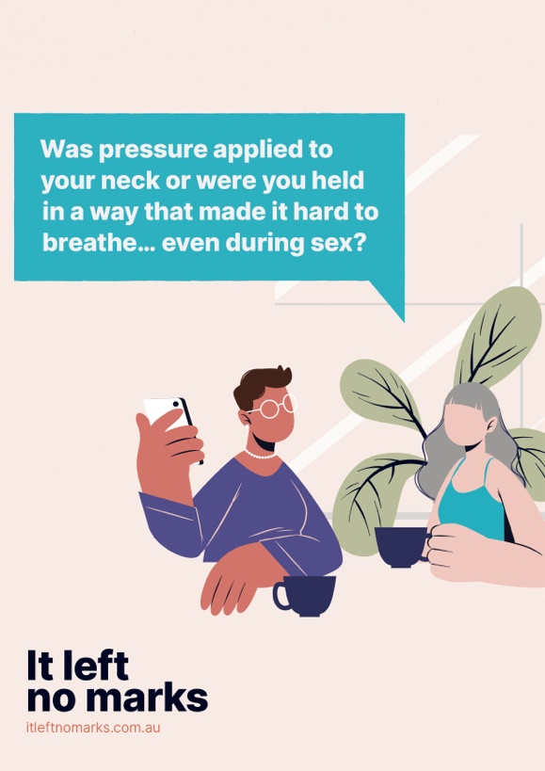Screening is the process of investigating the possible presence of a particular problem. Typically screening tools only gather small amounts of information, for example “Was pressure applied to the neck? Y/N.” Screening will prompt the service provider to either complete an assessment or provide a referral to someone who is able to complete an assessment. Assessments involve a more detailed questionnaire that defines the severity of non-fatal strangulation and acquired brain injury and identifies clients’ individual needs to devise a support plan and/or treatment strategy. In an assessment, a service provider might assess the client’s medical and safety needs and discuss with them what services are available to help them address those needs. The broad assessment categories in this referral pathway and protocol (see Figure 1 and Figure 2) are initial medical needs, safety needs, and short- and long-term needs. Additional assessment tools may also be used in conjunction with this protocol, including the DVSAT and specific medical protocols. Be aware of who is authorised to conduct an assessment in your workplace so you can refer to them if one   
is required.

#### Screening

The following question is provided as a guide for asking clients about strangulation in the context of violence or sexual choking: Was pressure applied to your neck or were you held in a way you couldn’t breathe, even during sex? This question can be modified in accordance with the client’s language, culture and life experiences, and can be supplemented with prompts. For example, to delve further into sexual choking, you could ask the client: Has anything been happening during sex that you are concerned about, or that makes you feel uncomfortable?   
If needed, follow this up with a more direct prompt for sexual choking: Some women I see mention being concerned about rough sex, including sexual choking. Is that something that worries you? These prompts will work better in a therapeutic setting after trust has been established.

##### Guidelines for screening:

1. Read the referral pathway and protocol before screening clients for strangulation or sexual choking.
2. Complete training on non-fatal strangulation and sexual choking before using this referral pathway and protocols. Revisit training using the online training modules at [Itleftnomarks.com.au](https://www.itleftnomarks.com.au/).
3. Screen new clients early to engage early intervention. Sometimes it can take time to build trust and rapport so be prepared to revisit screening tools at any stage during the client’s care.
4. Complete screening for strangulation when the client discloses a history of physical intimate partner violence but should also be completed for clients who report non-physical forms of domestic and family violence, including coercive control.
5. Ask clients who disclose experiences of strangulation about sexual choking. The first suggested question outlined in the paragraph above should cover both.
6. Use your professional judgement to determine if a screening for sexual choking is appropriate. Remember sexual choking may be present without violence.
7. Screen all clients for strangulation and sexual choking if they present with signs and symptoms associated with strangulation and a possible acquired brain injury   
   (see Figure 5: Significant signs and symptoms of strangulation).

#### Assessment

Assessment tools are the most accurate when staff are supported with training to use them, and have access to up-to-date referral information. When conducting an assessment for strangulation and sexual choking, service providers are reminded to work within their scope of practice. In some circumstances that will include using external protocols in conjunction with this protocol, such as medical protocols, safety assessment tools like the DVSAT, or legislation. If the client has not screened positive for strangulation or disclosed strangulation in another way, there is no need to conduct an assessment.

### Working with clients with suspected brain injuries

Experiences of strangulation and sexual choking can impact brain function and can lead to permanent brain injury. Evidence informs us that when a mild brain injury is managed well, most clients will make a full recovery. Accessing medical support immediately after sustaining a brain injury is important to assess the extent of the injury, but also to ensure the client has the information they need to help them manage their brain injury at home to potentially prevent permanent cognitive impairment. Getting a brain injury diagnosis can help clients to access a broader range of healthcare services, including allied health services that specialise in brain injury. A brain injury diagnosis may also help clients access social support through the National Disability Support Scheme ([NDIS](https://www.ndis.gov.au/)). There may be avenues to pay for this costly diagnosis through the NSW [Victims Support Scheme](https://victimsservices.justice.nsw.gov.au/). A brain injury diagnosis can also support just legal outcomes related to civil compensation.

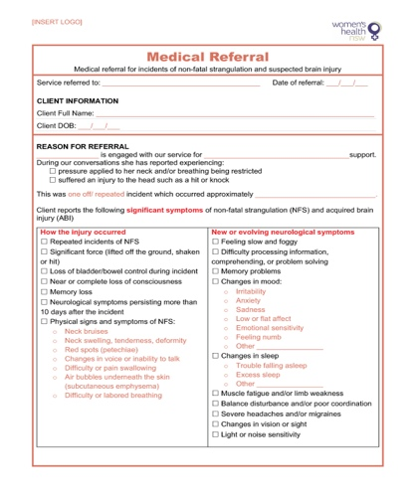Service providers should note that clients suffering from a brain injury may find it difficult to attend appointments or advocate for themselves during appointments. You can support clients by providing a warm referral, helping them set reminders for appointments, talking through how the client intends to get to the appointment, and providing them with a [medical referral letter](https://www.itleftnomarks.com.au/medical-referral-for-incidents-of-non-fatal-strangulation-and-suspected-brain-injury/) that details cognitive impacts and difficulties so that penalties for non-attendance are avoided.

### Medical case notes and record-keeping

The success of legal cases and compensation can be heavily impacted by documentation, particularly medical case notes. Service providers should be cognisant that their notetaking can impact the client’s ability to pursue a legal or compensatory outcome in the future. To improve skills in this area, please see the Ask Lois webinar on It Left No Marks: <https://www.itleftnomarks.com.au/strangulation-improving-responses-to-an-often-invisible-form-of-gender-based-violence/> or Women’s Legal Service NSW’s webinar on subpoenas and record keeping: <https://vimeo.com/759482129>. Some specific recommendations for case notes include ensuring legibility by typing, dating the notes, not using shorthand or abbreviations, and avoiding opinion unless it is substantiated by observations.

### Data collection

Service providers are advised to collect data, as analysis of this evidence can strengthen professional capacity to respond to women who experience strangulation and sexual choking.   
As strangulation rarely happens in isolation, and often includes shaking, or hits or blows to the head, we have included a category for traumatic brain injury among our four recommended data collection items:

* strangulation/choking/suffocation (violence)
* sexual choking (relationships)
* traumatic brain injury (self-reported)
* acquired brain injury (self-reported).

### Regular training

Regular training will help staff to feel confident using this referral pathway and protocol and support improved responses to strangulation, sexual choking and brain injury. Training will also prepare service providers to address myths surrounding strangulation, sexual choking and brain injuries, and engage in more effective health promotion. Standards for workplace training suggest that training on this organisational protocol should occur at induction, with supplementary training every year after that. Online training modules on strangulation, sexual choking and acquired brain injury can be accessed at [Itleftnomarks.com.au](https://www.itleftnomarks.com.au/).

#### Maintaining the currency of the referral pathway

Clinical supervision and team meetings are useful tools for standardising the way your organisation responds to strangulation, sexual choking and brain injury. These discussions can also be a good way to maintain the currency of your referral pathway.

**Ask staff:**   
What language are our clients responding to best? What referrals are getting good results for our clients? What positive outcomes have we had using these organisational tools? Do any services need to be removed after negative client feedback?

# Overview of the referral pathway flow.Referral pathway

## Disclosure of strangulation in the context of domestic, family and sexual violence

**If you receive a positive response after screening for strangulation, or if the client discloses strangulation in another way, consider whether you are the right person to delve further into the woman’s experiences.**

**Ask yourself:**   
Am I in the best position to ask further questions   
or is a warm referral to another staff member   
more appropriate?

If the client has experienced strangulation within the last 7 days, do not let her leave without reviewing her immediate medical and safety needs.

**Ask yourself:**   
Does this client require an interpreter?

### Response step 1: Initial medical response

Evaluate the client’s need for initial medical support based   
upon signs of life-threatening injury (Figure 4) and significant   
signs and symptoms of strangulation (Figure 5) that indicate   
medical red flags.

**The initial medical response is broken down into two sections:**

* **recent strangulation** (where the event or most recent event   
  of strangulation occurred within the last 7 days) and
* **historical strangulation** (when the event or events occurred more than 7 days ago).

When a client discloses strangulation, ask how long ago   
this occurred and follow the actions that relate to your client’s presentation.

**Figure 4: Signs of life-threatening injury. 
000 should be called immediately for clients displaying the below signs  
• Breathing difficulty 
• Neurological signs (near or complete loss of consciousness, confusion, responding inappropriately).

Figure 5: Significant signs and symptoms of strangulation.
About the strangulation incident: 
• Occurred in the last 7 days 
• Significant force (lifted off the ground or shaken during the incident) 
• Loss of bladder or bowel control 
• Loss of consciousness or memory
• Neck bruising, swelling, deformity or pain
• Changes in voice, difficulty swallowing, or air bubbles under the skin.

New or evolving neurological signs: 
• Neurological symptoms persisting more than 10 days after the event
• Feeling slow or foggy 
• Difficulty processing information 
• Memory problems
• Changes in mood or sleep 
• Muscle fatigue and/or limb weakness
• Balance disturbance
• Severe headaches and/or migraines 
• Changes in vision or sight 
• Light or noise sensitivity
   
**

|  |  |  |
| --- | --- | --- |
| Initial medical response:  Recent strangulation (within 7 days) | | Initial medical response:  Recent strangulation (more than 7 days) |
| **Signs of life-threatening injury** | | **New or evolving neurological symptoms** |
| Client presents with most recent incident of strangulation having occurred within the last  7 days. Client presents with signs and symptoms that indicate a life-threatening medical condition. | | Client presents with most recent incident of strangulation having occurred over 7 days ago. The client reports new or evolving neurological symptoms as defined in the significant signs and symptoms of strangulation figure (Figure 5). |
| **Action**   1. Call 000 and request an ambulance. 2. If there is a doctor or nurse onsite,  go and get them. 3. Do not leave the client alone.   **Considerations**   * If you are unsure whether the client has signs of life-threatening injury or you feel  it is necessary for an ambulance to be called, do so. | | **Action**   1. Using the [medical referral template](https://www.itleftnomarks.com.au/medical-referral-for-incidents-of-non-fatal-strangulation-and-suspected-brain-injury/) provide a warm referral to a primary healthcare service, including GP, nurse practitioner, neuro occupational therapist, neurophysiologist or specialised healthcare service. Referrals should be based upon client preference and appointment availability. Refer to your local contact cards or see the Statewide Service Directory for a list of possible services. |
| * Medical emergencies can be scary for both the client and first responders: continuing to talk to the client and seeking additional support early on can help reduce both your stress and the client’s.  Support to attend local EDClient presents with most recent incident of strangulation having occurred within the last 7 days. Client presents with or without significant signs and symptoms consistent with medical red flags for strangulation. **Action**   1. Use the [medical referral template](https://www.itleftnomarks.com.au/medical-referral-for-incidents-of-non-fatal-strangulation-and-suspected-brain-injury/) to support the client in attending a local emergency department (if it is safe for them to carry). This might include accompanying the client to the emergency department. 2. If the client has also experienced sexual assault, discuss options for a referral to [Sexual Assault Services.](https://www.health.nsw.gov.au/parvan/sexualassault/Pages/info-sexual-assault-victims.aspx) 3. Reiterate the importance of an initial medical assessment and provide the  client with information on when to seek immediate medical advice in case they  are delayed or choose not to attend an emergency department.   **Considerations**   * If you are unsure if the client has signs of life-threatening injury or you feel it is necessary for an ambulance to be called, do so. * If there are multiple emergency departments in your local area, discuss with the client the most suitable hospital for them to attend. Consider client safety; geographical location; hospital practice related to domestic, family and sexual violence presentations; the hospital’s ability to conduct forensic assessments following sexual assault; and client preference.   In some circumstances, clients may feel more comfortable attending a GP or attending a specialised healthcare service they are familiar with, for example, an Aboriginal medical service. Support the client’s decision-making and, where appropriate, assist them to make a timely appointment. Refer to your local contact cards or see the Statewide Service Directory (Figure 8) for a list of possible services. | 1. If the client experienced sexual assault in the last 14 days, and particularly if they are a child or young person, in consultation with the client, [Sexual Assault Servies](https://www.health.nsw.gov.au/parvan/sexualassault/Pages/info-sexual-assault-victims.aspx) should be contacted in order to discuss potential referral and forensic examination. 2. Reiterate the benefits to the client of seeking a medical assessment, including diagnosis of a brain injury, to get appropriate medical treatment and access additional health services; to prevent life-long injury; to receive expert medical advice; for support in applications for NDIS funding; and for evidence-gathering for legal and compensatory outcomes they may wish to pursue in the future (the client does not need to decide now; evidence can be collected and retained for future use).   **Considerations**   * The cost of healthcare services is a significant barrier for many clients. Discuss options for accessing the [NSW Victims Support Scheme](https://victimsservices.justice.nsw.gov.au/victims-services/how-can-we-help-you/victims-support-scheme/make-an-application.html) to assist clients in paying for healthcare services that are private or do not bulk bill. * Be aware that some emergency departments will accept patients who report historical incidents of strangulation. Referral to an emergency department for historical cases of strangulation should be based upon individual hospital practices and confirmed via phone call to the emergency department to avoid a potentially negative service experience for the client. * If required, contact [Synapse Australia](https://synapse.org.au/our-services/find-a-service/) for alternative services for clients with a suspected brain injury. * If the client is at risk of repeated incidents of strangulation, provide the client with information on when to seek emergency medical care. * Additional health promotion information and resources can be found at [Itleftnomarks.com.au.](https://www.itleftnomarks.com.au/strangulation/)   No significant signs or symptoms Client presents with most recent incident of strangulation having occurred over 7 days ago. The client does not report any new or evolving neurological symptoms as defined in the significant signs and symptoms table. **Action**   1. Deliver health promotion: 2. Clients should be advised to seek medical attention if they experience any new or evolving symptoms, or if they experience strangulation or a knock to the head again.   If the client is at risk of repeated incidents of strangulation or engages in sexual choking, provide them with information on when to seek medical advice. | |

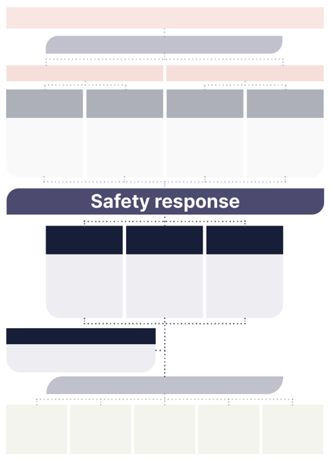Response step 2:   
Safety response

Consider the client’s safety needs.   
Assessment of safety needs may be supported by safety assessment tools such as the [DVSAT](https://sydneynorthhealthnetwork.org.au/wp-content/uploads/2022/09/Domestic-Violence-Safety-Assessment-Tool.pdf) or other pre-existing organisational safety assessment tools. Discuss all safety options with the client who is the expert in their own situation.

| Immediate danger | Domestic and family violence, no immediate danger | Sexual violence,  no immediate danger |
| --- | --- | --- |
| Client states they are, or they are observed to be, in immediate danger from physical harm or injury from the perpetrator and/or another person. | Client experienced strangulation as part of domestic and family violence. Client states they are, or they are observed to be, in no immediate danger from physical harm or injury from the perpetrator. | Client experienced strangulation as part of sexual violence. Client states they are, or they are observed to be, in no immediate danger from physical harm or further injury from the perpetrator. |
| **Action**   1. Call 000 and request police to attend the client’s location. 2. Inform your workplace supervisor or manager of the situation. 3. If the client is attending the service and there is fear the perpetrator will come to the service, follow workplace safety procedures, and ensure all gates and doors are secure. 4. If the client is not at the service centre (i.e. is on the phone or online), advise them to move to a safe space. This might include locking themselves in a room or moving to a safer location, such as a neighbour’s house. 5. Do not leave the client alone. If the client is on the phone or online, stay on the phone/platform with them until police arrive.   **Considerations**   * Situations like this can be scary for both the client and first responders. Continue to talk to the client and seek additional support to help reduce your stress and the client’s. * Additional health promotion information and resources on sexual choking can be found at [Itleftnomarks.com.au](https://www.itleftnomarks.com.au/strangulation/). | **Action**   1. Discuss reporting options with the client:    1. formal report to local NSW Police Domestic Violence Liaison Officer    2. formal reporting to local police station. 2. If your service does not provide domestic and family violence services, provide warm referral to a domestic and family violence service that can help the client with safety planning and risk mitigation. Refer to local contact cards or the Statewide Service Directory for a list of possible services. 3. If your service does provide domestic and family violence services, discuss risk mitigation with the client, and follow any internal procedures relating to their inclusion in local [Safety Action Meetings.](http://www.domesticviolence.nsw.gov.au/__data/assets/file/0014/301181/Safety_Action_Meeting_Manual_2017.pdf)   **Considerations**   * The process of risk mitigation is unique for each client. Consider the need for referrals to refuge and crisis housing for those ready to leave violent situations. Refer to your local contact cards or see the Statewide Service Directory for a list of possible services. * To support clients who wish to leave, discuss options for accessing financial aid like the [NSW Victims Support Scheme](https://victimsservices.justice.nsw.gov.au/victims-services/how-can-we-help-you/victims-support-scheme/eligibility-criteria.html) and the [Immediate Needs Package](https://victimsservices.justice.nsw.gov.au/victims-services/how-can-we-help-you/victims-support-scheme/financial-support/financial-assistance-for-immediate-needs/immediate-needs-support-package.html) for those experiencing domestic and family violence. * In some circumstances domestic and family violence and sexual violence coincide, and you will need to consider both safety responses. | **Action**   1. Discuss reporting options with the client:    1. formal report to local NSW Police Sexual Violence Portfolio Holder    2. formal reporting to the local police station    3. online reporting using the [Sexual Assault Reporting Option](https://portal.police.nsw.gov.au/adultsexualassault/s/sexualassaultreportingoption?language=en_US) (this portal provides the option to report anonymously, to be contacted at a later date if the offender has assaulted multiple people and police are building a criminal case against the perpetrator, or to request to be contacted by police to discuss formal reporting options). 2. If the client experienced sexual assault in the last 14 days, particularly if they are a child or young person, in consultation with the client, [Sexual Assault Services](https://www.health.nsw.gov.au/parvan/sexualassault/Pages/info-sexual-assault-victims.aspx) should be contacted in order to discuss potential referral and forensic examination.   **Considerations**   * In some circumstances domestic and family violence and sexual violence coincide and you will need to consider both safety responses. * Refer to your local contact cards or see the Statewide Service Directory for a list of possible services. |

|  |
| --- |
| Mandatory reporting |
| Client reveals a child (0 to 15 years) or young person (16 to 17 years) experienced strangulation  or was in the home while strangulation occurred. |
| **Action**   1. Use the [Mandatory Reporting Guide](https://reporter.childstory.nsw.gov.au/s/mrg) to assess the need to complete a mandatory report. 2. Mandatory reporting obligations should be discussed with and explained to the client.   **Considerations**   * Mandatory reporting is often stressful for the client due to fear of child removal, and for the service provider. Be transparent about when and why you are making a report. Reassure the client that it is not about taking children away, but about starting the process to ensure everyone’s safety.   While not an alternative to fulfilling mandatory reporting requirements, evidence relating to the intergenerational effects of violence supports keeping children in view when addressing violence against a mother by offering early intervention services to children whenever possible. |

### Response step 3: Short- and long-term responses

An effective response for those who experience strangulation includes an emergency response enacted during the initial crisis period, and access to services that provide long-term support throughout the client’s healing journey. Discuss with the client their short- and long-term needs to determine the types of services that would best meet their needs.

|  |  |
| --- | --- |
| Case management support | Clients who have experienced trauma, including incidents of strangulation, may have complex needs that require engagement with multiple services. Case management is specifically relevant for clients who have experienced strangulation on a regular and repeated basis, and those who may be suffering from an acquired brain injury. An effective response includes offering a warm referral to case management support to all clients with diverse and complex needs.  **Action**  Referral to case management support should be discussed with all clients who are engaging in one or more services, or who may be suffering from an acquired brain injury. Referral options should be discussed with the client, including accessing case management through specialised services. Refer to your local contact cards or see the Statewide Service Directory for a list of possible services offering case management support. |

|  |  |
| --- | --- |
| Mental, psychological, psychosocial and community support | Mental, psychological, psychosocial and community needs are interrelated and often services address these needs simultaneously, so they have been combined within this response step. There is a strong correlation between the needs arising from experiences of violence, mental health conditions, and brain injury. Every client who experiences strangulation in the context of violence should be supported to access mental, psychological, psychosocial and community support if desired.  **Action**  Discuss with the client available mental health services and, where possible, provide a warm referral to the client’s preferred service. Psychosocial support is client-specific and dependant on geographical location, accessibility and client preference. Clients should be informed of all available options for psychosocial support, including peer support groups, community activities and events, and advocacy options.  Consider:   * 1. counselling services   2. psychologists   3. psychiatrists who specialise in domestic, family and sexual violence   4. neuropsychologists   5. hotlines that provide 24-hour support   6. peer support groups   7. community activities and events.   See your local contact cards or the Statewide Service Directory for a list of specialised services offering mental, psychological, psychosocial and community support.  **Considerations**   * Healing from trauma is a very personalised experience shaped by a client’s unique cultural identity, structural inequities, and life experiences. We can help to restore agency after violence by respecting the values and life experiences of the client. Agency is promoted by providing a mental and emotional health response that explores a diverse range of services with the client to see what resonates.   Stigma associated with poor mental health can make clients reluctant to seek mental health support. You can help reduce client hesitation by providing warm referrals, offering culturally safe services, and offering peer support options. |

|  |  |
| --- | --- |
| **Medical  follow-up** | Client presents with most recent incident of strangulation having occurred more than 7 days ago. The client may have had an initial medical consultation; however, their health needs remain unmet or they have new or evolving neurological symptoms suggesting an acquired brain injury as defined in the significant signs and symptoms of strangulation figure (see Figure 5). **Action**   1. Using the [medical referral template](https://www.itleftnomarks.com.au/medical-referral-for-incidents-of-non-fatal-strangulation-and-suspected-brain-injury/) provide a warm referral to a primary healthcare service, including GP, nurse practitioner, neuro occupational therapist, neurophysiologist or specialised healthcare service. Referrals should be based upon client preference and appointment availability. 2. Reiterate the benefits to the client of seeking further medical assessment, including diagnosis of brain injury to support further treatment options, access to additional services, support to apply for NDIS funding, and evidence-gathering for potential criminal and legal cases they may wish to pursue in the future. 3. Allied and holistic health options should be presented to the client, including:    1. massage therapy    2. naturopathy    3. physiotherapy    4. speech pathology.   See your local contact cards or the Statewide Service Directory for possible available services.  **Considerations**   * The primary goal of accessing medical support beyond the initial phase of injury is to address the client’s physical health needs and to improve their quality of life. A brain injury diagnosis is not always necessary to achieve this, or desired by the client. * Diagnosing a brain injury is a complex process that can only be done by those trained to do so, and often involves multiple, lengthy and costly appointments. Discuss with the client what their goals are and ensure they are aware of what to expect when accessing these services. * Diagnosis of brain injury can carry with it a high level of stigma. Be aware of the negative associations with brain injury, including notions that a diagnosis may impact a client’s parenting, including legal matters relating to parenting. Balance these fears by providing the client with information about what a diagnosis might do to support them to manage better, including with their parenting, and offer to connect them to appropriate legal advice.   The cost of healthcare services is a significant barrier for many clients, so where possible free or low-cost services should be offered. Discuss options for accessing the [NSW Victims Support Scheme](https://victimsservices.justice.nsw.gov.au/victims-services/how-can-we-help-you/victims-support-scheme/make-an-application.html) to assist clients in paying for healthcare services that are private or those that do not bulk bill. |

|  |  |
| --- | --- |
| Legal support | Clients can access legal support to pursue criminal charges, civil claims and compensation claims. You can tell clients about these options and what to expect when accessing legal services, however legal advice should only be provided by those trained to do so.  **Action**   1. Explain to your client that there are multiple legal options they may wish to pursue in the future, including criminal charges, civil claims and victim’s compensation. Clients are to be made aware that there is no limitation period for strangulation so they can pursue a criminal outcome at any time.   If the client wishes to explore legal or compensatory options, you should discuss with the client what specialised services they may wish to engage with. Refer to your local contact cards or see the Statewide Service Directory for a list of specialised services offering legal support. |

|  |  |
| --- | --- |
| Children’s health and wellbeing | An effective multidisciplinary response keeps children in view even when the service does not work directly with children. You are to consider the intergenerational effects of violence and connect children and young adults present in the home for strangulation to early intervention services. You should also be cognisant that children may also be experiencing physical violence, including strangulation, from the perpetrator.  **Action**   1. Disclosures of children being present in the home or witnessing strangulation or other forms of violence should prompt you to connect clients and their children with early intervention services. Refer to your local contact cards or see the Statewide Service Directory for available services.   See also: “Mandatory reporting” page 16. |

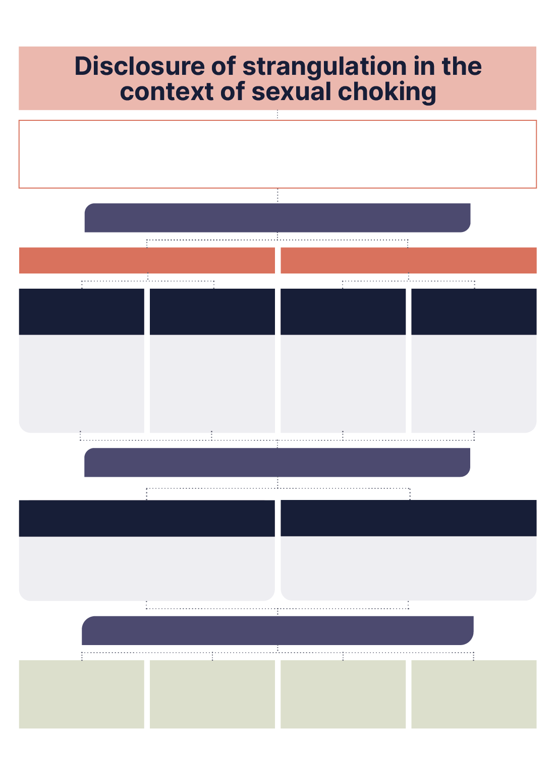

# Referral pathway

## Disclosure of strangulation in the context of sexual choking

**If you receive a positive response after screening for sexual choking, or if the client discloses sexual choking in another way, consider whether you are the right person to delve further into the woman’s experiences.**

**Ask yourself:**   
Am I in the best position to ask further questions or is a warm referral to another   
staff member more appropriate?

If the client has experienced sexual choking within the last 7 days do not let her leave without reviewing her immediate medical and safety needs.

Before continuing with an assessment or providing a warm internal referral, you also need to consider if an interpreter is required. An interpreter should be provided for all clients who are not fluent in English or who are d/Deaf.

### Response step 1: Initial medical response

Evaluate the client’s need for initial medical support based upon signs of life-threatening injury and significant signs and symptoms that indicate medical red flags for strangulation. The initial medical response is broken down into two sections: recent engagement in sexual choking (within 7 days) and historical engagement in sexual choking (more than 7 days). You are to determine the time since the client’s last experience of sexual choking, and how often the client engages in this practice, and follow the actions that relate to the client’s particular presentation.

Figure 6: Signs of life-threatening injury after sexual choking.
000 should be called immediately for clients displaying the below signs:  
• Breathing difficulty 
• Neurological signs (near or complete loss of consciousness, confusion, responding inappropriately).   

Figure 7: Significant signs and symptoms of sexual choking. 
Engagement in sexual choking: 
• Occurred in the last 7 days 
• Involved client being lifted off the ground 
• Resulted in loss of bladder or bowel control  
• Resulted in loss of consciousness or memory
• Resulted in neck bruising, swelling, deformity or pain
• Resulted in changes in voice, difficulty swallowing, or air bubbles under the skin.

New or evolving neurological signs: 
• Neurological symptoms persisting more than 10 days 
• Feeling slow or foggy 
• Difficulty processing information 
• Memory problems
• Changes in mood or sleep 
• Muscle fatigue and/or limb weakness
• Balance disturbance
• Severe headaches and/or migraines 
• Changes in vision or sight 
• Light or noise sensitivity.

|  |  |
| --- | --- |
| Initial medical response:  Recent engagement in sexual choking (within 7 days) | Initial medical response:  Historical engagement in sexual choking (more than 7 days) |
| **Signs of life-threatening injury** | **New or evolving neurological symptoms** |
| Client presents with most recent experience of sexual choking having occurred within the last 7 days. Client presents with signs and symptoms that indicate a life-threatening medical condition. | Client presents with most recent experience of sexual choking having occurred over 7 days ago. The client reports new or evolving neurological symptoms as defined in the significant signs and symptoms of sexual choking figure (see Figure 7). |
| **Action**   1. Call 000 and request an ambulance. 2. If there is a doctor or nurse onsite, go and get them. 3. Do not leave the client alone.   **Considerations**   * If you are unsure whether the client has signs of life-threatening injury or you feel it is necessary for an ambulance to be called, do so. * Medical emergencies can be scary for both the client and first responders: continuing to talk with the client and seeking additional support early on can help reduce your stress and the client’s.  Support to attend local ED Client presents with most recent experience of sexual choking having occurred within the last 7 days. Client presents with or without significant signs and symptoms consistent with medical red flags for sexual choking. **Action**   1. Health education and resources should be provided to the client where appropriate. Resources for clients engaging in sexual choking can be found at [Itleftnomarks.com.au](https://www.itleftnomarks.com.au/sexual-choking/). 2. You should explain to the client why you believe they require an immediate medical referral to an emergency department and, using the [medical referral template](https://www.itleftnomarks.com.au/medical-referral-for-incidents-of-non-fatal-strangulation-and-suspected-brain-injury/), support the client in attending a local emergency department or, failing that, a GP. Refer to your local contact cards or the Statewide Service Directory for available services. 3. Clients should be provided with the information on when to seek medical advice in the event they are delayed or choose not to attend an emergency department or a GP. Clients should be made aware that this information is a helpful reference every time they engage in sexual choking.   **Considerations**   * Clients engaging in sexual choking may be resistant to attending healthcare services because they feel sexual choking is common and risk-free, and they have not experienced negative health implications to date. Use the resources available to explain the health risks in a non-judgmental way to avoid isolating the client. * If you are unsure whether the client has signs of life-threatening injury or you feel it is necessary for an ambulance to be called, do so. * If there are multiple emergency departments in your local area, discuss with the client the most suitable hospital for them to attend. Consider geographical location and client preference. * In some circumstances, clients may feel more comfortable attending a GP or attending specific healthcare services, for example an LGBTQ+ health service. You should support clients’ decisions and, where appropriate, assist clients in making timely appointments. See your local contact cards or the Statewide Service Directory for a list of specialised health services. | **Action**   1. Health education and resources should be provided to clients where appropriate. Information for clients engaging in sexual choking can be found at [Itleftnomarks.com.au](https://www.itleftnomarks.com.au/sexual-choking/). 2. You should explain to the client why you believe they require a medical referral and, using the [medical referral template](https://www.itleftnomarks.com.au/medical-referral-for-incidents-of-non-fatal-strangulation-and-suspected-brain-injury/), provide a warm referral to a primary healthcare service (GP, nurse practitioner, neuro occupational therapist, neurophysiologist or specialised healthcare service). Referrals should be based upon client preference and appointment availability. See your local contact cards or the Statewide Service Directory for a list of specialist health services. 3. Provide the client with information on when to seek medical advice. Clients should be made aware that this information is a helpful reference every time they engage in sexual choking.   **Considerations**   * Clients engaging in sexual choking may be resistant to attending healthcare services because they feel sexual choking is common and risk-free, and they have not experienced negative health implications to date. Use the resources available to explain the health risks in a non-judgmental way to avoid isolating the client. * The cost of healthcare services can be a significant barrier for all clients. Discuss with the client free or low-cost options for accessing healthcare services and reiterate the importance of a medical assessment after engaging in sexual choking. * Be aware that some emergency departments will accept patients who report historical incidents of sexual choking. Referral to the emergency department for historical cases should be based upon individual hospital practices and confirmed via phone call to the emergency department to avoid a potentially negative service experience for the client. * If all of the above healthcare services are unavailable or unsuitable for your client contact [Synapse Australia](https://synapse.org.au/our-services/find-a-service/) for support finding alternative services for those with a suspected brain injury. * Additional health promotion information and resources about sexual choking can be found at [Itleftnomarks.com.au](https://www.itleftnomarks.com.au/strangulation/).  No significant signs or symptoms Client presents with most recent experience of sexual choking having occurred over 7 days ago. The client does not report any new or evolving neurological symptoms as defined in the significant signs and symptoms of sexual choking figure (Figure 7). **Action**   1. Deliver health promotion:    1. Clients should be advised to seek medical attention if they experience any new or evolving symptoms.    2. If the client is likely to engage in sexual choking in the future, provide the client with information on the health risks associated with sexual choking and when to seek medical advice. |
|  |

### Response step 2: Safety response

Consider if the client has any safety needs related to disclosures of sexual choking. You need to remain cognisant of the language you use when exploring the potential connection between sexual choking and violence, and you should avoid words or phrases that might be considered judgmental. Any reframing should be left to therapeutic sessions.

| Connected to violence | No connection to violence |
| --- | --- |
| Client makes a connection between their experiences of sexual choking and violence. | Client makes no connection between their experiences of sexual choking and violence. |
| **Action**   1. If the client identifies their experiences of sexual choking as an experience of violence, use the referral pathway for disclosures of strangulation in a violent context.   **Considerations**   * Be aware that some clients who are experiencing domestic, family and sexual violence may also be engaging in sexual choking and describing this practice as consensual. In this situation, continue to support your client’s safety needs related to their experiences of violence, alongside their experiences of sexual choking. | **Action**   1. If appropriate, outline that there can be legal consequences for the choker if someone is hurt as a result of engaging in sexual choking. |

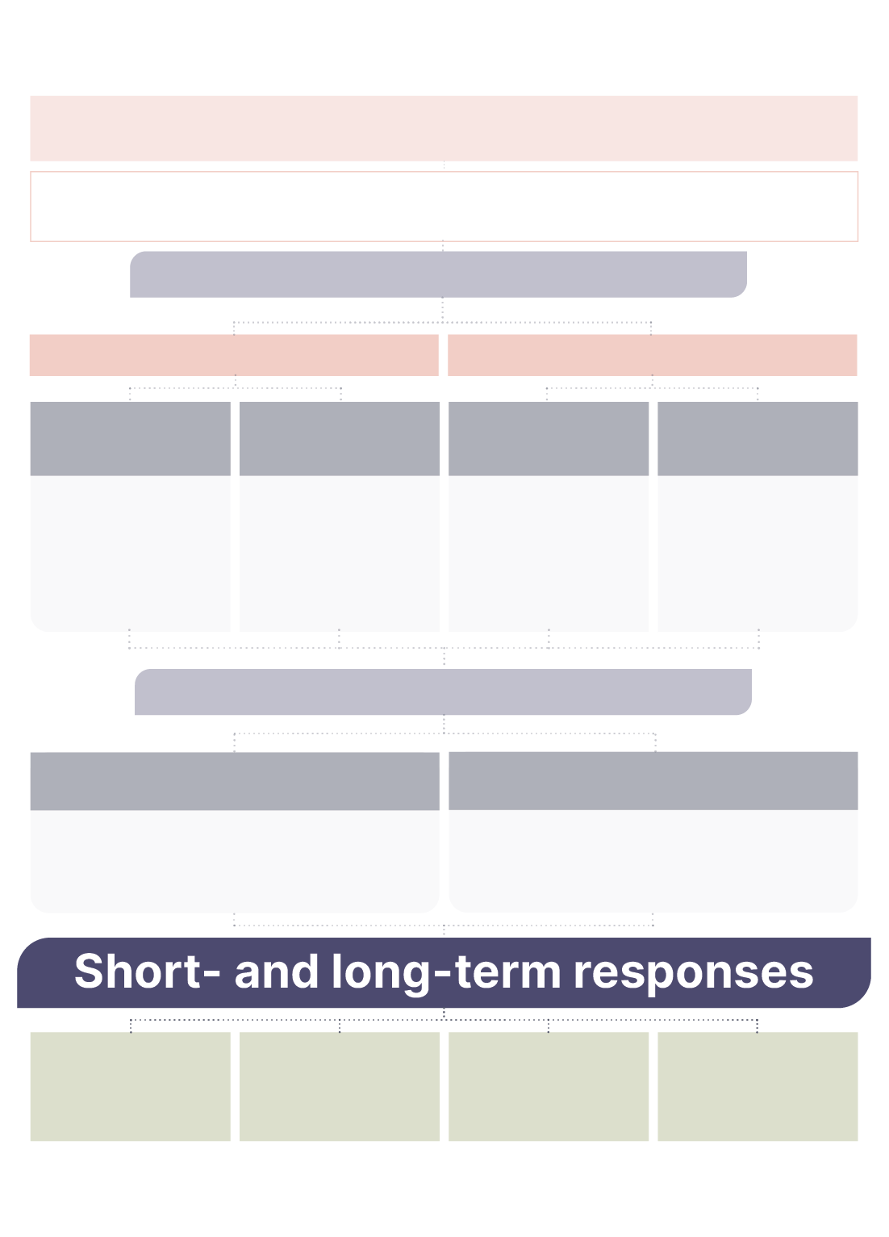

### Response step 3:

### Short- and long-term responses

Pressure to the neck that occurs in sexual choking can result in serious physical consequences, including a brain injury. These health impacts can further affect a client’s mental, emotional, psychological and psychosocial health.

An effective response for those who engage in sexual choking includes an immediate medical response enacted in the initial period after engaging in sexual choking, and support in accessing services that provide short- and long-term support that addresses all the client’s needs throughout their healing journey. You are to work with the client to determine what their short-   
and long-term needs are and what services they would like to   
engage with.

|  |  |
| --- | --- |
| Case management support | Clients engaging in sexual choking, specifically those who have engaged in sexual choking on a regular and repeated basis, may have several needs that require engagement with multiple services. This is specifically relevant for clients who may be suffering from a brain injury because of sexual choking. An effective response includes case management support for all clients with diverse and complex needs.  **Action**   * 1. Referral to case management support should be discussed with all clients who are engaging with one or more services. Referral options, including specialised services, should be discussed with the client. See your local contact cards or the Statewide Service Directory for a list of specialised service providers offering case management support. |

|  |  |
| --- | --- |
| Mental, psychological, psychosocial and community support | Mental, psychological, psychosocial and community support Mental, psychological, psychosocial and community needs are interrelated. Often, services address these needs simultaneously, so they have been combined within this response step. The evidence suggests frequent sexual choking is correlated with brain injury, cognitive decline and mental health impacts. Clients who engage in sexual choking should be connected to services that address their specific mental, psychological, psychosocial and community needs.  **Action**   1. Discuss available mental health services with the client and, where possible, provide warm referrals to the client’s preferred service. Mental health services may include:    1. counselling services, including specialised counselling services    2. psychologists    3. psychiatrists    4. neuropsychologists    5. mental health hotlines. 2. Psychosocial support is client-specific and dependant on geographical location, cultural safety, access and client preference. Clients should be informed of all available options for psychosocial support including:    1. local and online peer support groups    2. services hosting activities that support client wellbeing and connectivity to community.   See your local contact cards or the Statewide Service Directory for a list specialised services offering mental, psychological, psychosocial and community support. |

|  |  |
| --- | --- |
| Mental, psychological, psychosocial and community support | **Considerations**   * Healing from physical injuries caused by sexual choking is a very personalised experience shaped by a client’s unique cultural identity and life experiences. You should respect the values and individual stories of the clients you work with and allow for as much agency as possible. You can promote a client’s agency when providing a mental and emotional health response by exploring a diverse range of services to see which services resonate with them. * Social stigma associated with mental health issues can make clients resistant to seeking mental and emotional support. You can help reduce client hesitation by providing warm referrals, offering culturally safe services, and offering peer support options. |

|  |  |
| --- | --- |
| **Medical  follow-up** | Client presents with most recent experience of sexual choking having occurred over 7 days ago. The client has received an initial medical assessment; however, their health needs remain unmet, or they have new or evolving neurological symptoms as defined in the significant signs and symptoms of sexual choking figure (see Figure 7). Evidence of these signs may suggest an acquired brain injury. **Action**   1. Using the [medical referral template](https://www.itleftnomarks.com.au/medical-referral-for-incidents-of-non-fatal-strangulation-and-suspected-brain-injury/), provide a warm referral to a primary healthcare service, including GP, nurse practitioner, neuro occupational therapist, neurophysiologist or specialised healthcare service. Referrals should be based upon client preference and appointment availability. 2. Reiterate the benefits of seeking further medical assessment to the client, including diagnosis of brain injury to support further treatment options, access to additional health and community services, support for application for NDIS funding, and evidence-gathering for potential legal compensation claims they may wish to pursue in the future. 3. Alternative medical support options should be presented to the client, including:    1. massage therapy    2. naturopathy    3. physiotherapy    4. speech pathology. 4. The cost of healthcare services can be a significant barrier for many clients. Discuss with the client the potential costs of the appointment.   See your local contact cards or the Statewide Service Directory for a list of available services.  **Considerations**   * The primary goal of accessing medical support beyond the initial phase of injury is to address the client’s physical health needs and to improve their quality of life. A brain injury diagnosis is not always necessary to achieve this or desired by the client. * Diagnosing a brain injury is a complex process that can only be done by those trained to do so and often involves multiple, lengthy and costly appointments. Discuss with the client what their goals are and ensure they are aware of what to expect when accessing these services. * Diagnosis of brain injury can carry with it a high level of stigma. Be aware of the negative associations with brain injury, including notions that a diagnosis may impact a client’s parenting, including legal matters relating to parenting. Balance these fears by providing the client with information about what a diagnosis might do to support them to manage better, including with their parenting, and offer to connect them to appropriate legal advice. |

|  |  |
| --- | --- |
| Legal support | Some clients may wish to seek a legal outcome or compensation for injuries sustained during sexual choking. You can present legal service options to the client and discuss what to expect when accessing legal services, however legal advice should only be provided by those trained to do so.  **Action**   1. Where appropriate, present the potential for a legal or compensatory outcome to clients whose engagement in sexual choking has resulted in injury. 2. If the client wishes to explore legal or compensatory options, discuss with the client what specialised services they may wish to engage with.   See your local contact cards or the Statewide Service Directory for a list of specialised services offering legal support. |

# Statewide Service Directory

## Initial medical response

|  |  |
| --- | --- |
| Service provider | Details |
| Emergency departments | Emergency departments provide 24/7 unscheduled, outpatient care for clients requiring immediate medical care. Public hospital emergency departments are free for Medicare holders. Find your nearest emergency department in New South Wales and approximate wait times here: <https://www.emergencywait.health.nsw.gov.au/> |
| Sexual assault services | Sexual Assault Services (SAS) provide specialised medical care for individuals who have experienced sexual assault, including forensic medicine and the collection of evidence. NSW Health has a network of SAS in every local health district within New South Wales and selected public hospitals. SAS operate 24/7: <https://www.health.nsw.gov.au/parvan/sexualassault/Pages/health-sas-services.aspx> |
| Women’s health centres | Women’s health centres (WHCs) are community-based feminist services run by women for women. WHCs provide a range of services to address holistic health and wellbeing needs for clients who identify as women: <https://whnsw.asn.au/womens-health-centres-nsw/> |
| Aboriginal and Torres Strait  Islander health services | Aboriginal community-controlled health organisations (ACCHOs) are primary healthcare services initiated and operated by local Aboriginal community members. ACCHOs are a culturally appropriate healthcare service for Aboriginal and Torres Strait Islander clients:  <https://www.naccho.org.au/naccho-map/> |
| Brain injury services | Synapse, Australia’s brain injury organisation, provides a range of support services for people who have been impacted by brain injury and disability. Synapse can provide resources and information on brain injury for service providers and clients, and help clients connect with health and service providers who understand the unique aspects of brain injury. Call 1800 673 074 or visit <https://synapse.org.au/our-services/find-a-service/> |

## Safety response

| **Service provider** | **Details** |
| --- | --- |
| 1800RESPECT | 1800RESPECT is the national domestic, family and sexual violence support service that offers 24/7, free and confidential counselling, information and support: <https://www.1800respect.org.au/> |
| Domestic Violence NSW (DVNSW) | DVNSW is an independent, non-government peak organisation that provides a representative and advocacy function for specialist domestic and family violence services. Find a service in your area: <https://www.dvnsw.org.au/about-us/our-members> |
| Women’s Domestic Violence Court Advocacy Service (WDVCAS) | WDVCAS is a free service for women experiencing domestic and family violence anywhere in New South Wales. WDVCAS can provide services and individuals, including children, who are experiencing domestic and family with information, advocacy and referral: <https://www.legalaid.nsw.gov.au/my-problem-is-about/my-family-or-relationship/domestic-and-family-violence/womens-domestic-violence-court-advocacy-services#accordion-63699f123a-item-4551958860> |
| Women’s health centres | Women’s health centres (WHCs) are community-based feminist services run by women for women. WHCs provide a range of services to address holistic health and wellbeing needs for clients who identify as women: <https://whnsw.asn.au/womens-health-centres-nsw/> |
| NSW Police | Clients can report crimes like strangulation, sexual violence, and domestic and family violence to the police. If additional support is needed, ask for the Domestic Violence Liaison Officer or the Sexual Violence Portfolio Holder at your local area command (LAC). If the client does not want to speak directly with a police officer, but wants the police to know she has been sexually assaulted, you can complete the online Sexual Assault Reporting Option (SARO) through the community portal: <https://portal.police.nsw.gov.au/adultsexualassault/s/sexualassaultreportingoption?language=en_US> |
| Sexual assault services | Sexual Assault Services (SAS) provide specialised medical care for individuals who have experienced sexual assault, including forensic medicine and the collection of evidence. NSW Health has a network of SAS in every local health district within New South Wales and selected public hospitals. SAS operate 24/7: <https://www.health.nsw.gov.au/parvan/sexualassault/Pages/health-sas-services.aspx> |

## Short- and long-term response

| Service provider | Details |
| --- | --- |
| Domestic, family and sexual violence support services | The NSW Domestic Violence Line offers 24/7, free counselling and referral services for those who have experienced domestic and family violence: call 1800 656 463. |
| Full Stop Australia offers 24/7 confidential, trauma specialist counselling for people of all genders who are impacted by violence and abuse, as well as their friends, colleagues and family members: <https://fullstop.org.au/> |
| Women’s Domestic Violence Court Advocacy Service (WDVCAS) is a free service for women experiencing domestic and family violence anywhere in New South Wales. WDVCAS can provide services and individuals, including children, who are experiencing domestic and family violence with legal information and support: [https://www.legalaid.nsw.gov.au/my-problem-is-about/my-family-or-relationship/domestic-and-family-violence/womens-domestic-violence-court-advocacy-services - accordion-63699f123a-item-4551958860](https://www.legalaid.nsw.gov.au/my-problem-is-about/my-family-or-relationship/domestic-and-family-violence/womens-domestic-violence-court-advocacy-services#accordion-63699f123a-item-4551958860) |
| Brain injury | Synapse, Australia’s brain injury organisation, provides a range of support services for people who have been impacted by brain injury and disability. Synapse can provide resources and information on brain injury for service providers and clients, and help clients connect with health and service providers who understand the unique aspects of brain injury: <https://synapse.org.au/our-services/find-a-service/> |
| Women’s support services | Women’s health centres (WHCs) are community-based feminist services run by women for women. WHCs provide a range of services to address holistic health and wellbeing needs for clients who identify as women: <https://whnsw.asn.au/womens-health-centres-nsw/> |
| Women’s Legal Service NSW (WLS NSW) provides free and confidential legal advice and referrals to women in New South Wales. WLS NSW can provide expert legal advice and support to clients seeking legal outcomes, including those related to domestic, family and sexual violence, injury as a result of sexual choking, and family law: <https://www.wlsnsw.org.au/legal-services/> |
| Older women’s support services | The Older Women’s Network NSW (OWN NSW) is a peak organisation that consults on issues impacting older women, including violence and abuse, homelessness, and health: <https://ownnsw.org.au/> |
| Children and young people  support services | Headspace is Australia’s national youth mental health foundation and supports 12- to 25-year-olds. Headspace provides young people with mental health, physical health (including sexual health), and alcohol and other drug services, as well as work and study support: <https://headspace.org.au/> |
| Kids Helpline provides free, 24/7 counselling for those aged 5 to 25 years old. Children and young people can call the Kids Helpline for any reason at any time: <https://kidshelpline.com.au/> |
| Aboriginal and Torres Strait Islander support services | The NSW Child, Family and Community Peak Aboriginal Corporation (AbSec) is a not-for-profit, incorporated Aboriginal-controlled organisation that focuses on child protection and out-of-home care policy advice on issues affecting Aboriginal children, young people, families and carers: <https://absec.org.au/> |
| 13YARN provides 24/7 over-the-phone crisis support to Aboriginal and Torres Strait Islander people. 13YARN is a confidential and culturally safe hotline: <https://www.13yarn.org.au/> |
| Wirringa Baiya provides culturally safe, state-wide legal advice for Aboriginal and Torres Strait Islander clients: <https://www.wirringabaiya.org.au/services> |
| LGBTQ+ support services | ACON offers low-cost health, counselling, support and advocacy services for LGBTQ+ people across  New South Wales: <https://www.acon.org.au/> |
| Inner City Legal Centre (ICLC) provides legal advice and support for the LGBTIQ community: <https://www.iclc.org.au/our-services/lgbtiq-legal-advice/> |
| Disability support services | Northcott is a not-for-profit disability service provider offering a range of services, including clinical support, group and individual services for both adults and children, allied health and clinical support, housing, and support coordination: <https://northcott.com.au/locations> |
| Refugee support services | STARTTS offers a range of culturally safe services for refugees and their families living in Australia, including but not limited to counselling and therapy, group work, health education, psychiatric assessment and treatment, and physiotherapy: <https://www.startts.org.au/about-us/> |
| Multicultural legal services | Multicultural Legal Service (MLS) offers free legal services to multicultural people living in Western Sydney, including migrants, refugees, asylum seekers and people who are culturally and linguistically diverse. Service provision for those living outside Western Sydney is assessed on a case-by-case basis: <https://www.wsclc.org.au/programs/multicultural-legal-service-mls/> |
| Sex worker support services | Sex Worker Outreach Project (SWOP NSW) is a community-based peer education sex worker organisation. SWOP NSW focuses on access to health, safety, human rights and workplace protections, and can provide information, support and advocacy for clients who work as a sex workers: <https://swop.org.au/> |
| Inner City Legal Centre (ICLC) provides free legal advice to anyone who identifies as a sex worker in New South Wales: <https://www.iclc.org.au/our-services/sex-worker-legal-service/> |
| Restorative justice services | The Restorative Justice Service is managed by the NSW Department of Communities and Justice. Restorative justice is an approach that focuses on the rehabilitation of offenders through reconciliation with victims and the community. Restorative justice options are suitable for clients who wish to pursue alternative justice outcomes: <https://correctiveservices.dcj.nsw.gov.au/support/restorative-justice.html> |
| Recognition payment | The Victims Support Scheme provides counselling, financial assistance and recognition payment to victims of acts of violence, including domestic, family and sexual violence, that occurred in New South Wales:  <https://victimsservices.justice.nsw.gov.au/victims-services/how-can-we-help-you/victims-support-scheme.html> |

**Published by:**

Women’s Health NSW. PO Box 341, Leichhardt NSW 2040.

[www.whnsw.asn.au](http://www.whnsw.asn.au/)

**Acknowledgment**

This material was produced as part of the NSW Sexual Violence Project Fund administered by the NSW Department of Communities and Justice.

Women’s Health NSW gratefully acknowledges the financial and other support it has received from the NSW Government, without which this work would not have been possible.

**Creative Commons Licence**

With the exception of the Women’s Health NSW branding, content provided by third parties, and any material protected by a trademark, all material presented in this publication is licensed under a Creative Commons Attribution-NonCommercial 3.0 Australia (CC BY-NC 3.0 AU) licence. The full licence terms are available at creativecommons.org/licenses/by-nc/3.0/au/legalcode